ABSTRACT

**REMOTE CONTROL SYSTEM FOR AUTOMATIC TEMPERATURE CONTROL IN THE PROCESS OF OYSTER MUSHROOM CULTIVATION USING RASPBERRY PI**

Remote control system to maintain temperature stability is one of the technology development by utilizing a microcontroller as a web server container. Web server that serves as an information center that will assist in controlling remotely using the internet.

Smartphone becomes one very important requirement at this time, because a smartphone can do many things one can access a web-connected to the Internet network.

In this study, temperature stability can be in control anywhere and anytime. Microcontroller connected to the web server will provide information log data room temperature incubation. The advantages of this system is that it can in control of the remote by turning on the fan as a media protector at room temperature incubation in order to grow oyster mushrooms ideal.

Keywords: system, control, microcontroller, web server, internet, smartphone, temperature, incubation, oyster mushrooms and ideal.

Material Project List :

1. Raspberry Pi 2 B
2. MCP 3008
3. TMP36
4. Small DC Fan
5. Driver Motor L298N

Monitoring Graph in Plot.ly as Webserver

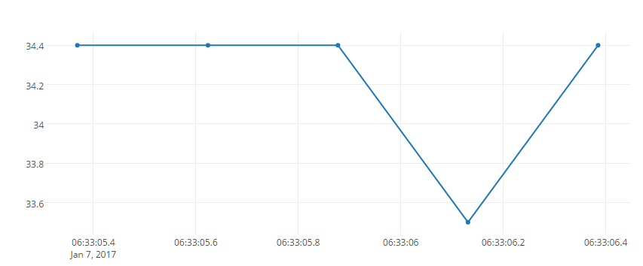

Source : <https://plot.ly/~irkham3/0/#data>

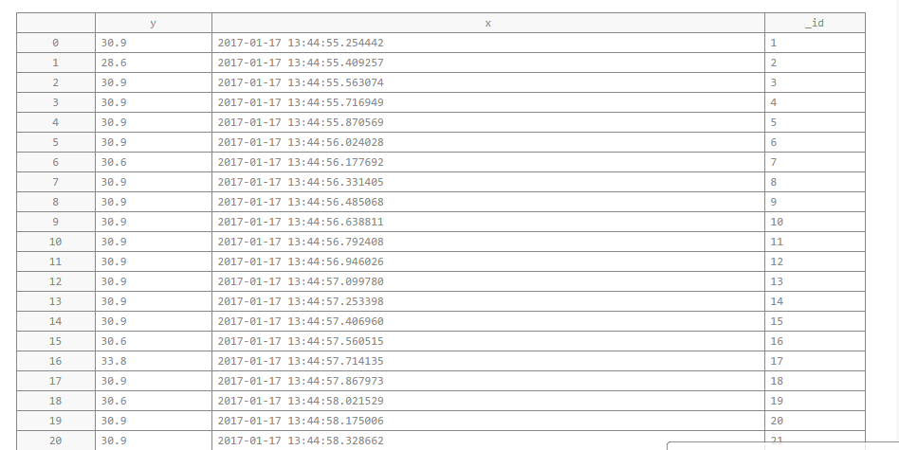

Source : <https://plot.ly/~irkham3/0/#data>